HANU Training Management System

Use-Case-Realization Specification: View Digital Invoice (Student)

Version 1.0

Revision History

| **Date** | **Version** | **Description** | **Author** |
| --- | --- | --- | --- |
| 07/12/2021 | 1.0 | Draft | Nguyen Dieu Huong Ly |
|  |  |  |  |
|  |  |  |  |
|  |  |  |  |

Table of Contents

1. Introduction 2

1.1 Purpose 2

1.2 Scope 2

1.3 Definitions, Acronyms, and Abbreviations 2

1.4 References 2

1.5 Overview 2

2. Flow of Events—Design 2

3. Derived Requirements 2

Use-Case-Realization Specification: View Digital Invoice (Student)

# Introduction

## Purpose

This document describes how the View Digital Invoice Use-Case is realized within the design model, in terms of collaborating objects.

## Scope

This document is strictly associated with the View Digital Invoice (Student) Use-Case.

## Definitions, Acronyms, and Abbreviations

Student – a person who studies in Hanoi university.

## References

[1]View Digital Invoice (Student) **–** Use Case Specification, Nguyen Dieu Huong Ly., December 06, 2021, HANU’s Training Management System.

## Overview

The flow of events that were introduced textually in the use-case specification. The following section contains diagrams (sequence and class diagrams) describing how the use case is realized in terms of collaborating objects. If there are any additional needs derived from the realized diagrams, such as non-functional requirements or other requirements not included in the design model, they will be stated in section 3 – Derived Requirements.

# Flow of Events—Design

## Sequence diagram

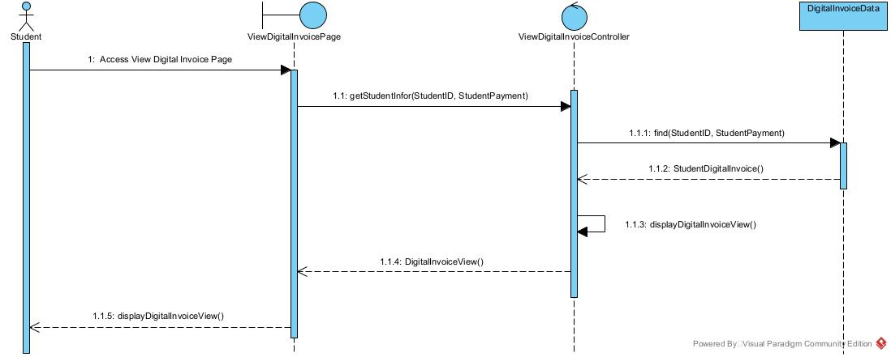

## Class diagram

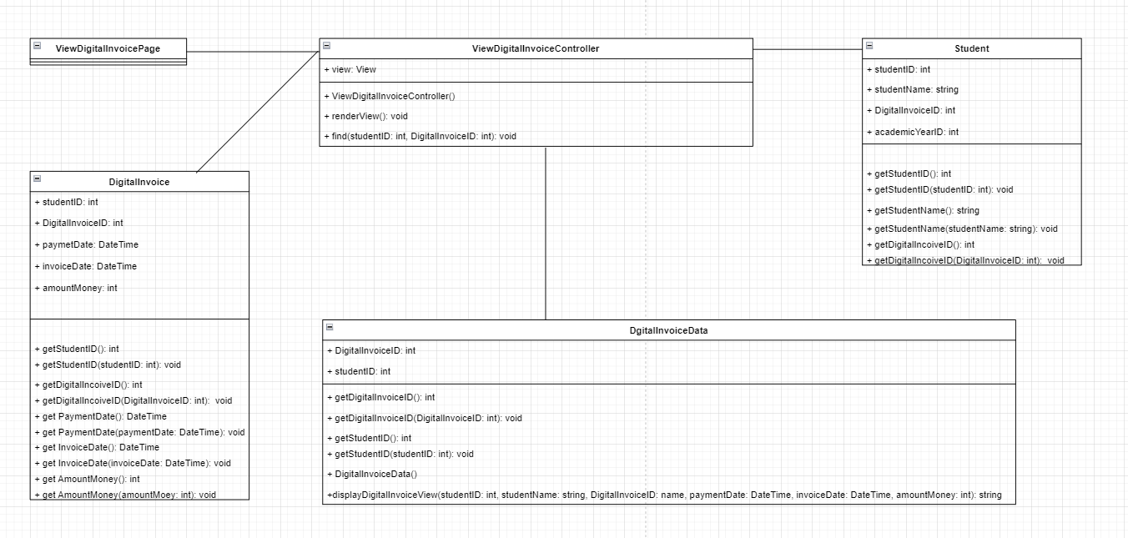

# Derived Requirements